Pushing after a conflict resolution
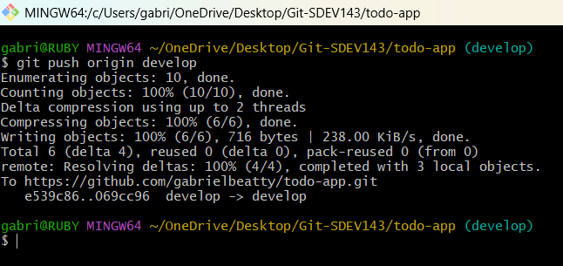

Check Branch Location
Use git checkout
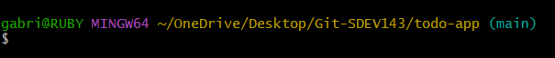

Review branch diff
